Practice - 6.1:

Code:

byte[] values = new byte[10];

Arrays.fill(values, (byte) 1);

Code:

int num[] = {7,7,6,6,5,5,4,4};

for(int i = 0; i < 8; i = i + 2)

System.out.print(num[i]);

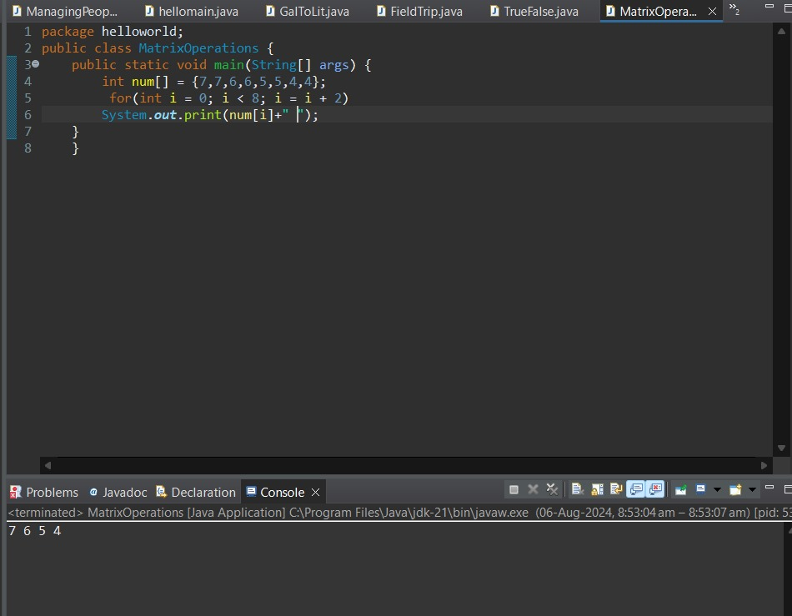

Code:

int[][] num = {{3, 3, 3}, {2, 2, 2}};

int[] array = {4, 3, 2};

for (int i = 0; i < 3; i++) {

num[1][i] = num[0][i] + array[i];

}

for (int i = 0; i < 2; i++) {

for (int j = 0; j < 3; j++) {

System.out.print(num[i][j]);

}

System.out.println();

}



Code:

import java.util.Scanner;

public class TestScores {

public static void main(String[] args) {

Scanner scanner = new Scanner(System.in);

int[] scores = new int[5];

int sum = 0;

System.out.println("Enter 5 test scores:");

for (int i = 0; i < 5; i++) {

scores[i] = scanner.nextInt();

sum += scores[i];

}

double average = sum / 5.0;

System.out.println("Average score: " + average);

}

} 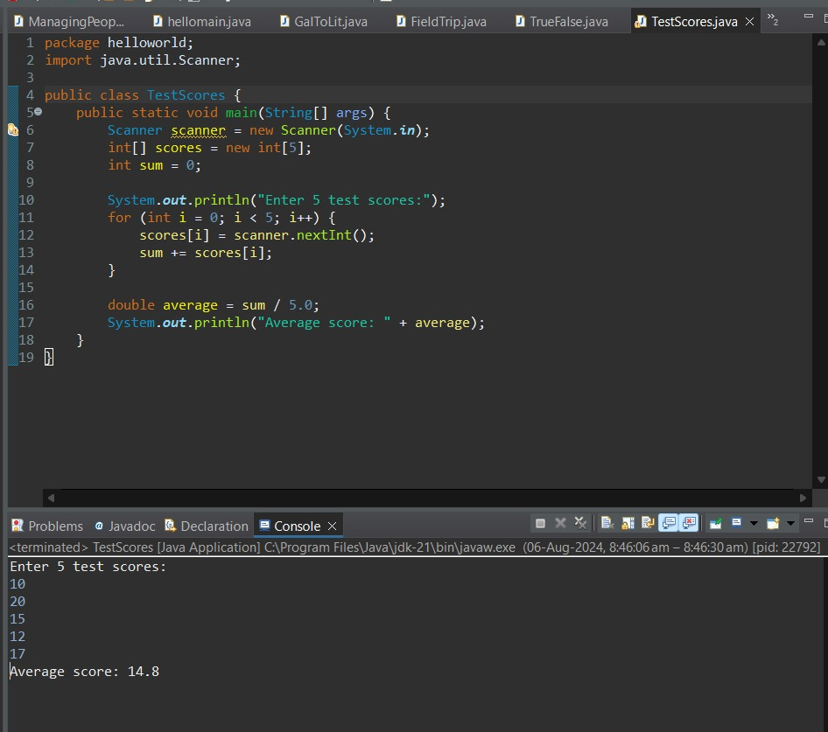

Code:

import java.util.Scanner;

public class MatrixOperations {

public static void main(String[] args) {

Scanner scanner = new Scanner(System.in);

int[][] matrixA = new int[2][2];

int[][] matrixB = new int[2][2];

boolean matricesEntered = false;

while (true) {

System.out.println("Menu:");

System.out.println("a. Enter Matrix A");

System.out.println("b. Enter Matrix B");

System.out.println("c. Display A + B");

System.out.println("d. Display A - B");

System.out.println("e. Display A \* B");

System.out.println("f. Exit");

char choice = scanner.next().charAt(0);

switch (choice) {

case 'a':

System.out.println("Enter Matrix A:");

matrixA = enterMatrix(scanner);

matricesEntered = true;

break;

case 'b':

System.out.println("Enter Matrix B:");

matrixB = enterMatrix(scanner);

matricesEntered = true;

break;

case 'c':

if (matricesEntered) {

System.out.println("A + B:");

displayMatrix(addMatrices(matrixA, matrixB));

} else {

System.out.println("Enter both matrices first.");

}

break;

case 'd':

if (matricesEntered) {

System.out.println("A - B:");

displayMatrix(subtractMatrices(matrixA, matrixB));

} else {

System.out.println("Enter both matrices first.");

}

break;

case 'e':

if (matricesEntered) {

System.out.println("A \* B:");

displayMatrix(multiplyMatrices(matrixA, matrixB));

} else {

System.out.println("Enter both matrices first.");

}

break;

case 'f':

System.exit(0);

break;

default:

System.out.println("Invalid choice.");

break;

}

}

}

private static int[][] enterMatrix(Scanner scanner) {

int[][] matrix = new int[2][2];

for (int i = 0; i < 2; i++) {

for (int j = 0; j < 2; j++) {

matrix[i][j] = scanner.nextInt();

}

}

return matrix;

}

private static void displayMatrix(int[][] matrix) {

for (int i = 0; i < matrix.length; i++) {

for (int j = 0; j < matrix[0].length; j++) {

System.out.print(matrix[i][j] + " ");

}

System.out.println();

}

}

private static int[][] addMatrices(int[][] matrixA, int[][] matrixB) {

int[][] result = new int[2][2];

for (int i = 0; i < 2; i++) {

for (int j = 0; j < 2; j++) {

result[i][j] = matrixA[i][j] + matrixB[i][j];

}

}

return result;

}

private static int[][] subtractMatrices(int[][] matrixA, int[][] matrixB) {

int[][] result = new int[2][2];

for (int i = 0; i < 2; i++) {

for (int j = 0; j < 2; j++) {

result[i][j] = matrixA[i][j] - matrixB[i][j];

}

}

return result;

}

private static int[][] multiplyMatrices(int[][] matrixA, int[][] matrixB) {

int[][] result = new int[2][2];

for (int i = 0; i < 2; i++) {

for (int j = 0; j < 2; j++) {

result[i][j] = matrixA[i][0] \* matrixB[0][j] + matrixA[i][1] \* matrixB[1][j];

}

}

return result;

}

}

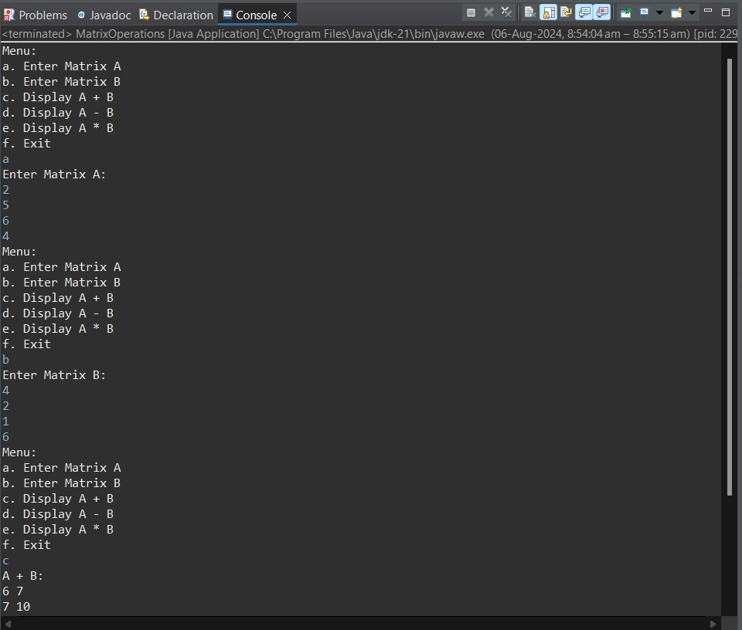

Code:

import java.util.Arrays;

import java.util.Collections;

import java.util.Scanner;

public class Main {

public static void main(String[] args) {

Deck d = new Deck();

d.shuffle();

d.print();

Hand playerHand = new Hand();

Hand dealerHand = new Hand();

// Deal two cards to player and dealer

playerHand.addCard(d.dealCard());

playerHand.addCard(d.dealCard());

dealerHand.addCard(d.dealCard());

dealerHand.addCard(d.dealCard());

Scanner scanner = new Scanner(System.in);

boolean playerTurn = true;

while (playerTurn) {

System.out.println("Player's hand: " + playerHand);

System.out.println("Total points: " + playerHand.getPoints());

if (playerHand.getPoints() > 21) {

System.out.println("Player busts! Dealer wins.");

return;

}

System.out.print("Would you like another card? (yes/no): ");

String response = scanner.nextLine();

if (response.equalsIgnoreCase("yes")) {

playerHand.addCard(d.dealCard());

} else {

playerTurn = false;

}

}

while (dealerHand.getPoints() < 16) {

dealerHand.addCard(d.dealCard());

}

System.out.println("Dealer's hand: " + dealerHand);

System.out.println("Total points: " + dealerHand.getPoints());

if (dealerHand.getPoints() > 21 || playerHand.getPoints() > dealerHand.getPoints()) {

System.out.println("Player wins!");

} else if (playerHand.getPoints() < dealerHand.getPoints()) {

System.out.println("Dealer wins!");

} else {

System.out.println("It's a tie!");

}

}

}

class Deck {

Card[] cardArray = new Card[52];

int topCardIndex = 0;

Deck() {

int suits = 4;

int cardType = 13;

int cardCount = 0;

for (int i = 1; i <= suits; i++) {

for (int j = 1; j <= cardType; j++) {

cardArray[cardCount] = new Card(i, j);

cardCount++;

}

}

}

public void shuffle() {

Collections.shuffle(Arrays.asList(cardArray));

topCardIndex = 0;

}

public Card dealCard() {

if (topCardIndex < cardArray.length) {

return cardArray[topCardIndex++];

}

return null; // No cards left

}

public void print() {

for (Card card : cardArray) {

System.out.println(card);

}

}

}

class Card {

String suit, name;

int points;

Card(int n1, int n2) {

suit = getSuit(n1);

name = getName(n2);

points = getPoints(name);

}

public String toString() {

return "The " + name + " of " + suit;

}

private String getName(int i) {

if (i == 1) return "Ace";

if (i == 2) return "Two";

if (i == 3) return "Three";

if (i == 4) return "Four";

if (i == 5) return "Five";

if (i == 6) return "Six";

if (i == 7) return "Seven";

if (i == 8) return "Eight";

if (i == 9) return "Nine";

if (i == 10) return "Ten";

if (i == 11) return "Jack";

if (i == 12) return "Queen";

if (i == 13) return "King";

return "error";

}

private int getPoints(String n) {

if (n.equals("Jack") || n.equals("Queen") || n.equals("King") || n.equals("Ten"))

return 10;

if (n.equals("Two"))

return 2;

if (n.equals("Three"))

return 3;

if (n.equals("Four"))

return 4;

if (n.equals("Five"))

return 5;

if (n.equals("Six"))

return 6;

if (n.equals("Seven"))

return 7;

if (n.equals("Eight"))

return 8;

if (n.equals("Nine"))

return 9;

if (n.equals("Ace"))

return 11;

return -1;

}

private String getSuit(int i) {

if (i == 1) return "Diamonds";

if (i == 2) return "Clubs";

if (i == 3) return "Spades";

if (i == 4) return "Hearts";

return "error";

}

}

class Hand {

private Card[] cards = new Card[5];

private int cardCount = 0;

public void addCard(Card card) {

if (cardCount < cards.length) {

cards[cardCount++] = card;

}

}

public int getPoints() {

int totalPoints = 0;

int acesCount = 0;

for (int i = 0; i < cardCount; i++) {

totalPoints += cards[i].points;

if (cards[i].name.equals("Ace")) {

acesCount++;

}

}

while (totalPoints > 21 && acesCount > 0) {

totalPoints -= 10;

acesCount--;

}

return totalPoints;

}

public String toString() {

StringBuilder handString = new StringBuilder();

for (int i = 0; i < cardCount; i++) {

handString.append(cards[i]).append("\n");

}

return handString.toString();

}

} 